April 2020

Victoria Robinson
Hi, I’m Victoria. I am 12.5 years old, and I am in Year 7 at Belmont Christian College, Newcastle, NSW. At the moment I am doing remote online learning at home and missing seeing my friends. Although I do enjoy wearing my own clothes, not my school uniform, and I get to eat gummy bears in English.
The sport I enjoy the most is swimming. I was a bit disappointed when COVID-19 caused the school swimming carnivals to be canceled, as this is my first year in High School and I was looking forward to new challenges in the school swimming competitions. I was also looking forward to catching up with other multi-class swimmers from around the State. I am a member of the NUSwim club, and we train at Newcastle University. This year I qualified for the Swimming Australia Age Championships in Perth, but they were canceled too.
My massive sporting goal is to go to the Paralympics for swimming. My short-term goal is to be accepted into the SNSW Para development squad. To achieve that goal I need to train hard and improve my PBs. COVID-19 has put a hold on my normal training. To work around this I am training in our pool with a bungee cord for endurance and a wetsuit because it is cold. I’m also doing daily core strengthening exercises set by my physio.
One of my proudest sporting achievements was in 2019 when I went to the School Sports Australia Track and Field Championships in Darwin. I competed in Discus and the relay. In the 12 years girls multi-class Discus I came 3rd. I really enjoyed the competition atmosphere in Darwin. Athletics isn’t my favourite sport and I don’t do much training for it, but I don’t mind competing.
I am classified as a multi-class athlete because when I was three years old I was diagnosed with a brain tumour. During surgery to reduce the size of the tumour I had a stroke, which caused me to have mild left hemiplegia. My body is asymmetric and I wear an AFO on my left leg. My primary school sports teacher encouraged me to get classified for athletics and swimming.
When the quarantine is over I am looking forward to seeing my friends and returning to swimming training. My advice during isolation is to get outside for a walk each day if you can.
​
Victoria shared with us how she is studying and training during the COVID-19 lockdown which required many to study, work and train from home. Victoria has shared a video of her home swimming training for us all. It is very cold and she has to wear a wet suit!
​
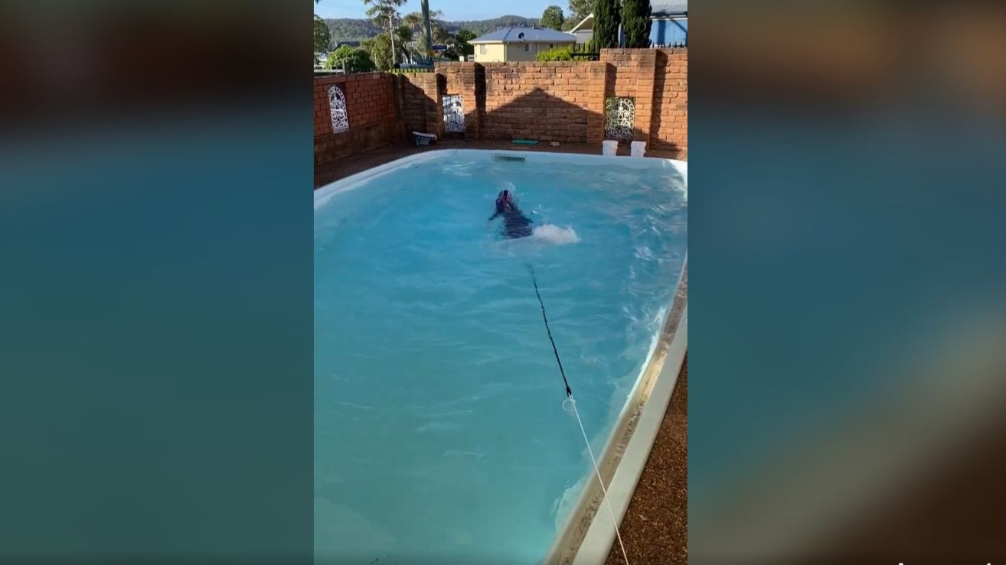

Watch here: https://www.facebook.com/cpsportrec/videos/249180512967561

