May 2020

Indiana Cooper
Hi, I am Indi. I am 14 yrs old and I am in grade 9 at Gundagai High School. I was born at 24 weeks weighing 780g. I was in hospital for 125 days because I was suffering a grade 1 and grade 2 bleed on the brain which resulted in dystonic Cerebral Palsy in all four of my limbs.
I play able-bodied league tag for the Gundagai Tigers and we have won the last 3 Grand Finals and I scored a try in the first Grand Final that I played in! I play soccer with the Cerebral Palsy Alliance and was also invited to the first ever Asia-Oceania Regional Female Cerebral Palsy (CP) Football Camp at Valentine Sports Park in Sydney from October 8 to 12. Indi was one of the youngest players in the camp of squad girls being selected to attend from Australia and Japan.
​I compete in Athletics and enjoy the 100m, 200m, 400m and 800m. I have also competed in the Australian Cross Country Championships for the past 3 years.
I would love to represent Australia one day at the Paralympics. I am also training very hard to try to qualify for the World Para Junior Championships and hopefully the Commonwealth Games.
​I have a lot of great moments in athletics but winning gold at the Pacific School Games in 800m a few years ago and gaining the Pacific Games record for my classification was pretty awesome!
​After school, I would like to pursue a career in coaching or something sport-related for sure!
​I was just announced on the Athletics NSW Target Talent Program for junior athletes. I was very happy to make the TTP as I feel I can learn a lot from the experienced coaches available.

Indiana shared with us how she is training during the COVID-19 lockdown which required many athletes to study, work and train from home. Indi has shared a video of her home running training for us all. Below is a video of Indi running past her training partners up an inclined road for running training!
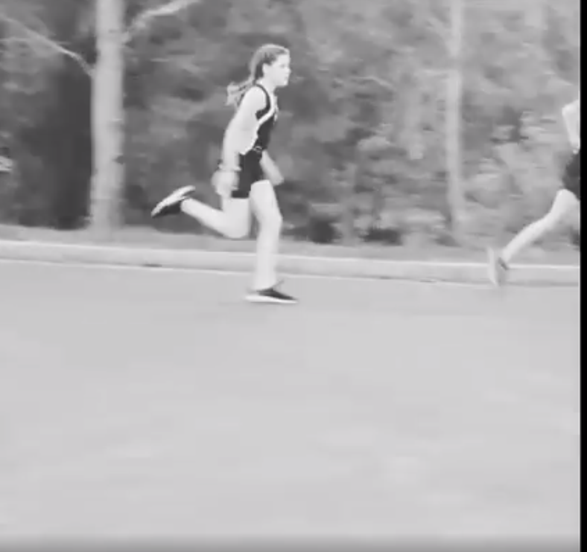
Watch here: https://www.facebook.com/cpsportrec/videos/3047959551908428

